Greenbridge: Scattered Site Lots (6)
Introduction

Greenbridge is the only new master planned community in the southwest portion of unincorporated King County. The master plan offers multiple varying development opportunities on the 95-acre site.

Greenbridge is in its final stages of development and has been in planning and construction for over 23 years.

King County Housing Authority (KCHA) is offering 6 scattered site lots adjacent to Greenbridge to be sold to developers for for-sale housing.

Greenbridge offers:
- 472 rental units in a wide mix of architectural styles, colors, bedroom mix and levels of affordability
- Over 300 for sale market rate homes
- A main street that features 130,000 SF of community space
- A 450-student K-5 school
- The Jim Wiley community center including a Boys and Girls Club in addition to other community services
- Educare early learning center
- King County public library branch
- Adult education opportunities offered by Highline College and YWCA
- Retail space including The Greenbridge Café and Dubsea Coffee
- 12 parks and trails
- Over 80 pieces of public art
- View corridors of Mt. Rainier and the Olympic Mountains
- Expanded transit and bus shelters
- Express bus service, 13 minutes to Downtown Seattle

The January 2025 Offering

This offering consists of 6 scattered site lots. The lots are not part of the Greenbridge subdivision and will need to have building permits with storm drainage improvements. Frontage improvements will either need to be modified or constructed for each lot. There is water, sewer, power and communications in the streets for connections to franchise utility providers.

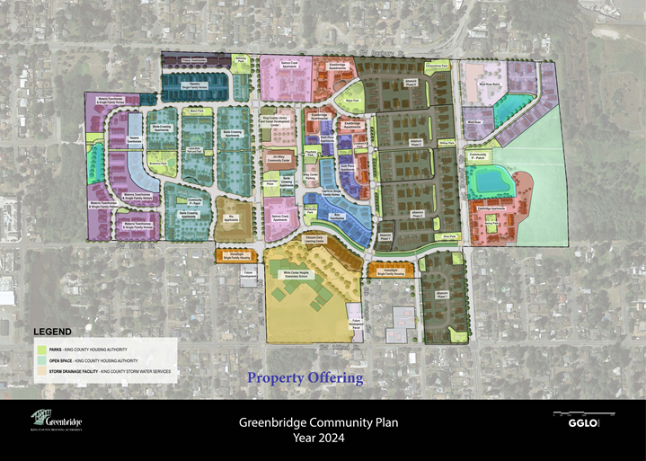

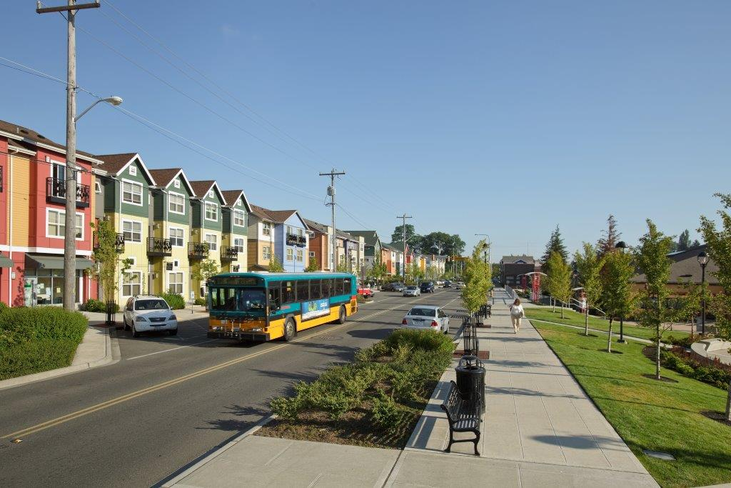
The Neighborhood

Greenbridge is located in the White Center neighborhood of unincorporated King County. White Center is between the cities of Seattle to the north and Burien to the south. The immediate neighborhood is primarily single family residential with commercial development along the main arterials. The central commercial core, 8th Ave SW, is lined with wide sidewalks, street trees, bus stops and Gateway Park on SW Roxbury Street. Businesses include Dubsea Coffee, The Greenbridge Café, I Care Vision Center, The Miller School of Art and the KingCounty Public Health Clinic. Greenbridge is located four blocks east of downtown White Center and close to the Olsen Place/Myers Way Park and Ride Lot. The neighborhood is well served by commercial services in White Center and is only blocks from the Westwood Village shopping center.

Transportation

Highway access is provided by north/south arterials including SR 509, a limited access freeway extending from S 188th St north to Seattle. Other major north/south arterials include 1st Ave S, 16th Ave SW and Des Moines Memorial Drive S.

East/West arterials servicing this area include SR 518, a limited access freeway at the north end of SeaTac International Airport, which connects with I-405 and I-5 on the east and SR 509 on the west. This provides direct connection to Pacific Hwy S and I-5 east of SeaTac International Airport.

King County Metro Transit provides convenient access from the Greenbridge site to downtown Seattle, Southcenter, West Seattle and the Eastside. Greenbridge is also connected to downtown White Center and West Seattle by walking trails and established bike routes.

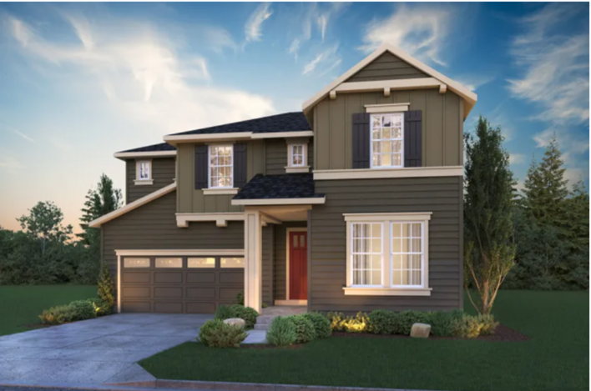

Commuting Times from Greenbridge

Greenbridge is centrally located in the Puget Sound Region. It is 35 minutes or less from all major employment centers in King County, as shown below, and 37 minutes from the Tacoma job center.

Destination Minutes

Auburn ........................ 32 minutes
Bellevue ...................... 27 minutes
Federal Way ................ 26 minutes
Kent ............................. 25 minutes
Redmond ..................... 34 minutes
Renton ......................... 18 minutes
Seattle .......................... 15 minutes
Tacoma ........................ 37 minutes
Tukwila ........................ 15 minutes

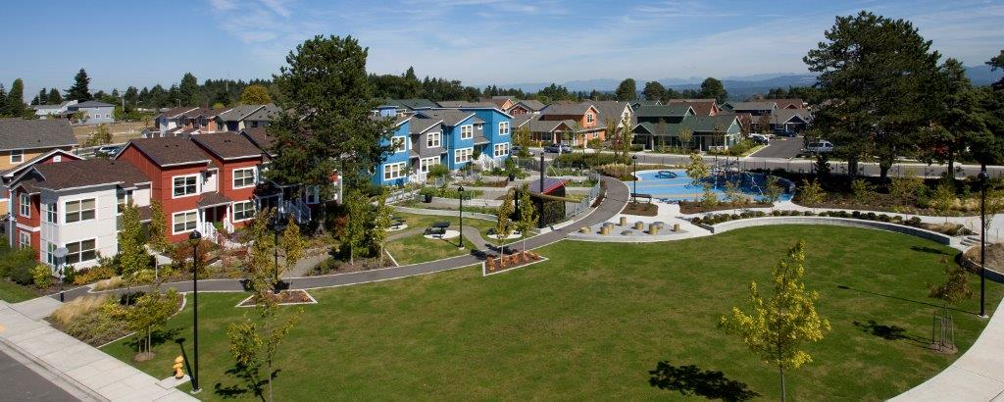
Information for Interested Parties

Land made available under this offering shall be developed by the developer/builder for sale to owner-occupants. KCHA intends to enter into a contract for this property with one developer/builder who will own and develop the property from start to finish. The land may not be resold or assigned by the developer/builder to another land developer or builder.

KCHA has constructed extensive infrastructure improvements for Greenbridge. These include 12 parks, community trails, storm drainage systems and new utilities including water and sewer systems.

The developer/builder’s responsibilities will include, at their own expense, costs associated with the remaining infrastructure frontage improvements (roads, storm conveyance, sewer, water, power, cable, etc.) required to serve the lots being developed, including:

- All franchise utility design, engineering and surveying of property
- All applicable submittal, review and approval costs and permits
- Construction of all infrastructure per approved permits
- Design, permitting and construction of housing improvements, including home construction and lot landscaping
- Repair or replacement, at developer/builder’s expense, any damage to public improvements or utilities at the Greenbridge site caused by Buyer’s construction activities.

Special Conditions Related to Property Sale

- Design Guidelines
Developer/builder is required to follow the Greenbridge Design Guidelines and design review process set forth in the Design Guidelines published with this land offering.

- Greenbridge Association
The 6 lots are adjacent to property that is part of the Greenbridge Association but are not included within the Association.

Sale Process

KCHA is offering the 6 lots without a broker. For questions about the sale, the site, and the development please contact John Eliason at JohnE@kcha.org.

Site Access to Interested Parties

Prospective developer/builders must visit the site and familiarize themselves with general site conditions and the overall Greenbridge development prior to the submission of offers.

Sales Offer Requirements

For the property prospective buyers must submit an application package that contains:

- A schematic site plan and elevations of proposed housing
- Proposed home sales price schedule and floor plan
- A description of the development company including the company’s experience with projects and housing products
- Names and resumes of key management and supervisory personnel who will be responsible for the development
- A permitting, development and sales schedule
- A non-binding Letter of Intent.

KCHA reserves the right to decline any and all offers at any time prior to entering into a binding purchase and sale agreement.

Greenbridge Property for Sale

Property | 6 scattered site lots adjacent to Greenbridge for market rate home development
Price | Price should be based on the market rate for the best residential use of the land
Zoning | R-18 and R-12

Below are the anticipated proposal review and negotiation steps. This offering will remain open and a buyer can submit a proposal at any time for review. A proposal may be submitted on a portion of the 6 lots.

Proposal Review and Negotiation Steps

- Offering issued: January 2025
- 1st round review: TBD
- KCHA staff will review the Proposals
- Selection of best offer: TBD
- Complete Purchase and Sale Agreement: TBD
- Feasibility: TBD
- Closing of Property: TBD

Property offers will be reviewed for price and quality of housing planned to meet the Greenbridge Design Guidelines. The selection of the most qualified offer will not be based solely on price but will be based on a combination score of company experience, housing quality and price.

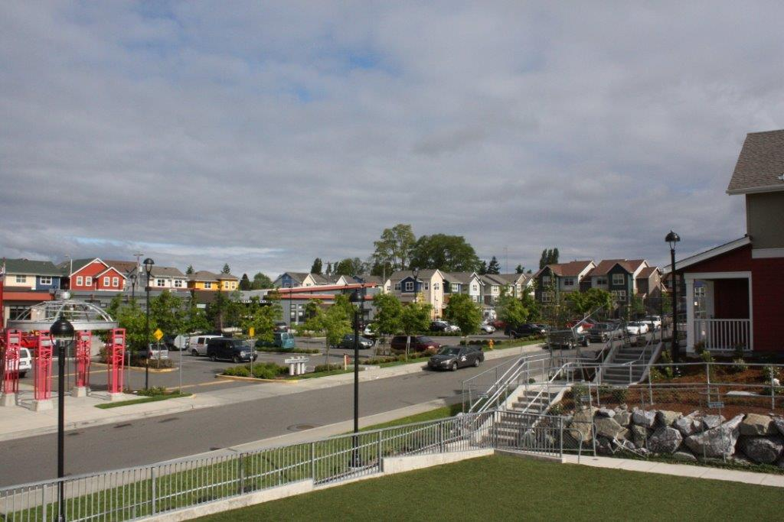
Additional Information Available to Download from Offering on KCHA Website
- January 2025 Property Offering
- Design Guidelines
- Survey
- Title Reports
- Letter of Intent (LOI) Form

Applicable Permitting Jurisdictions
- Building Permits: King County Local Services
2. Sewer District: Southwest Suburban Sewer District
3. Fire District: North Highline Fire District
4. School District: Highline School District #401
5. Power: Seattle City Light
6. Phone: Lumen
7. Cable: Comcast
8. Gas: Puget Sound Energy
9. Water: Seattle Public Utilities (SPU) and Water District 20.

